News From the NeuroRelational Perspective
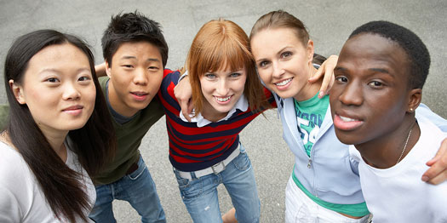 |  | The PersonBrain Model  Relate Well…  React Less!
 |  | whats new: The NeuroRelational model is gaining popularity among child and youth services around the globe!

A NeuoroRelational Skillset that empowers trained individuals to recognize their clients mental condition, and respond in the most effective manner. Recognition of the brain state of the client is critical to determining the best set of reimbursements! The PersonBrain Model provides the necessary skills to recognize a client’s brain state, and respond with the most appropriate therapeutic strategies to encourage young people to become the best that they can be!
Trainer of the Month: Cindy Ford
This is a great place to spotlight a trainer or participant with a new or good idea.

Organizational Development!
To view column breaks, section breaks, and other formatting marks, on the Home tab, in the Paragraph group, click the paragraph mark icon.
With the growing focus of government bodies on our at-risk youth population, The PersonBrain Model, among other trainings available, stands ready to prepare front line staff for working with children and youth!

